Instant Messaging for creating interactive and collaborative
m-Learning environments

Dr James Kadirire
Anglia Ruskin University
England

Abstract

Instant Messaging (IM) and Presence, which is essentially the ability of being able to detect if other users are logged in on the network, and send them messages in real time, has become one of the most popular applications of the Internet, causing people to want to stay connected to the Internet for inordinate amounts of time, and fostering a sense of "online community", that perhaps no other application has done (Alvestrand, 2002). This research¹ looks at the use of mobile devices to send instant messages which can carry much more information than the short message service messages, but would be free to use except for the price of getting online. The IM system presented showed that IM can be a viable means of communicating and learning in higher education establishments. There is some evidence to show that learning with mobile devices is good at reducing the formality of the learning experience, engaging reluctant learners and raising self-confidence. Unlike in a face-to-face classroom, in online distance education, attention needs to be paid into developing a sense of community in the group of participants in order for the learning process to be successful and IM is a natural medium for online community building and asynchronous/synchronous peer discussions.

Keywords: instant message; mobile device; wireless; presence; chat; authentication; database

Introduction

Most industry analysts expect that mobile phones and portable digital assistants (PDAs), will merge into one and the introduction of the General Packet Radio Service (GPRS), Enhanced Data GSM Environment (EDGE) and Universal Mobile Telecommunications System (UMTS)/3G networks, has made it possible to browse the web or hold a video-conference from a mobile phone. The potential offered by these developments is huge, particularly in education, where not only the short message service (SMS), but also instant messaging (IM) can be used. Mobile devices have truly become ubiquitous and pervasive, with over 2 billion mobile users worldwide, sending 235 billion SMS messages in the first quarter of 2006 (Latest Mobile, GSM, Global, Handset, Base Station, & Regional Cellular Statistics, April 2006). Although SMS is quick and easy to use, it comes at a cost, not only in monetary terms, but also in the maximum number of characters that can be used for a message.
Instant Messaging and Presence, which is essentially the ability of being able to detect if other users are logged in on the network, and send them messages in real time, has become one of the most popular applications of the Internet, causing people to want to stay connected to the Internet for inordinate amounts of time, and fostering a sense of "online community" that perhaps no other application has done (Alvestrand, 2002). IM is becoming widespread in universities for online discussions, chatting, file transfer, library usage, et cetera. Some of the most common IM applications are AOL Instant Messenger, MSN Messenger, Yahoo Messenger, and Google Talk. All support avatars (a movable icon representing a person in cyberspace or virtual reality graphics), in addition to user icons. IM has become the latest employee productivity tool. A customer-service representative can use it as a quick and easy way to answer an inquiry, whereas a salesperson can inform a busy vice president about a new account. Gartner estimates that 70% of corporate employees rely on IM while at work (Korzeniowski, 2004). According to the research conducted by (Lenhart and Shiu 2004), 42% of Internet users in the USA (about 53 million Americans), use IM and it’s appeal is apparent amongst young adults and technology enthusiasts. Research carried out at Wake Forest University (Walker, 2005) has shown that student mobile phone usage patterns are moving away from more traditional messaging like e-mail to newer technologies such as IM and SMS. This should encourage students to be more engaged with course material outside the classroom as well as communicate better among themselves. Very often students want to communicate or locate other people using their notebooks or mobile phones while in indoor environments, for instance, in a meeting room, lecture theatre, or inside a large building.
The most revolutionary aspect of mobile technology is perhaps that it addresses the problem of social inclusion. Many young people who wouldn't go near a university or who don't own a computer do own a mobile phone. A three year pan-European research project carried out by Kadirire et. al., at Anglia Ruskin University, and it’s European partners into mobile learning (m-Learning) found that learning with mobile devices was good at reducing the formality of the learning experience, engaging reluctant learners and raising self-confidence (Kadirire, 2005), (Attewell, 2004). McGuire et. al., on the e-Viva research project at Anglia Ruskin University, funded by the Qualifications and Curriculum Authority (QCA), enabled Key Stage 3 students to take part in assessments by answering pre-recorded questions over their mobile phones (Walton, 2005). The research showed that teachers believed that mobile phone usage made pupils much more aware of what they were doing and why they were doing it. Knowing that their work was going to be seen by others has a positive effect and increases their motivation and self confidence. Research in mobile learning in classrooms by (Roibas and Sanchez, 2002) has also shown that the way forward in mobile learning in formal educational settings is the introduction of handheld devices. The research carried out in the Numina project at the University of North Carolina at Wilmington, (Vetter, Heath, Herman, Lugo, Reeves, Ward, 2005) suggests that students enjoy the technology and become more active in their learning when handheld pocket computers are used in the classroom and that there is every indication that in the near future wireless data devices will be as widespread as wireless voice devices are now. Experience with the very successful Anglia Ruskin University 100% online degree has shown that when students were asked to evaluate the effectiveness of their online learning experience, it is the ability to engage in asynchronous discussions with their peers that they value most (Ultralab: BA Hons. Learning, Technology and Research, 2006). Unlike in a face-to-face classroom, in online distance education, attention needs to be paid into developing a sense of community in the group of participants in order for the learning process to be successful and IM is a natural medium for online community building and asynchronous peer discussions.

This research¹ looks at the use of mobile devices (mobile phones and PDAs) to send instant messages which can carry much more information than text or SMS messages, but would be free to use except for the price of getting online and downloading any content. Mobile telephone operators in the United Kingdom, charge GPRS/3G users on the amount of the data downloaded in kilobytes. If the IM arrives while the user is not online, it can be stored in a database and when the user logs on, he or she can retrieve their messages, rather like email. With technologies such as web-enabled and IEEE 802.11x enabled mobile phones and PDAs, IEEE 802.11x networks, also known as Wireless Fidelity (Wi-Fi) hotspots, mobile wireless communications are well on their way to becoming pervasive. So, for those mobile phones that are Wi-Fi enabled like the Nokia N80 and the Sony Ericsson P990i, with fully working web browsers, connection and usage costs become less of an issue as they can connect to their campus networks, surf the Web and take part in IM sessions, all for free. Users can also logon to the Internet via their wireless access points at home, if they have a broadband connection, which will not cost them anything in terms of accessing the Internet via their mobile phones. This will also make online distance learning much more attractive as it will break down the “distance” and the user will only be aware of the online community, irrespective of where they are physically located.
The rest of the paper is structured as follows: the next section on “System Design” looks at the “Instant Message Environment” viz. what components an IM system needs to have, as well “Content Adaptation” viz. how does one adapt content which is normally designed for normal sized computer display screens, to fit onto a small mobile device, typically with a 200x300 pixel screen resolution. This is followed by the sections on the “System Architecture”, the “Mobile Devices Used”, the “Results”, “Discussion and Conclusion” and finally the section on “Future Research”.
System Design – The Instant Message Environment
The system is essentially based on the idea of a community of students within some educational establishment. The instant message environment is composed of multiple features or components, some of which are:
User identity – This identifies the valid user of the system and in our system, it’s made up of the user name and password for authentication.
User Profile/Microportal – In all instant messaging systems, it is important for the users within an online community to be able to find out basic information about the other users without having to ask anyone. So, even though IM messages will only be exchanged amongst registered and authenticated users, it is important to be able to look up any user and get details about them. These details will be what each user wants the other users to know about them, like their sex, age, their picture, interests, et cetera. This is provided via a user profile or microportal which is created dynamically when each user logs on. A microportal is a small version of a portal and has essentially the same meaning as a portal. A portal is a web-based (http-based) application that commonly provides personalization, single sign-on, and content aggregation from different sources, and hosts the presentation layer of information systems. Aggregation is the process of integrating content from different sources within a web page (Kadirire, 2005a). For the purpose of this research, we define a microportal as a web-based application that is essentially a simpler and smaller version of a portal, but specifically targeted at mobile devices. Also, from within their microportal, users can access learning content from a learner management system (LMS) as shown in Figure 1.
User Database or Directory – This is the main database which stores all the system users and has a list of those that are also currently logged in. In this research, we used an Oracle 9i database running on Windows 2000.
Presence Awareness– This is the ability to determine if a user is logged on. We implement this by setting a flag in the database tables when a user is logged on and resetting it when they log off. So, it’s a simple matter of querying the database to display a list of the users that are logged on. When users are logged onto the system, they will appear on a contacts list of online users. From this list, it should be possible to invite a selected user for a private synchronous chat or a one-to-one instant messaging session
Instant Messages – these have been implemented very much like email. The messages are stored in the database and if a user is logged on, they will receive a notification by an unopened mail-message icon to alert them of the new IM. They can reply to this IM straight away or choose not to if they wish.
Asynchronous chat – If a user is not online and the other user knows their user identification/name they use in the system, they can send them an IM which will be stored in the database and when they next login, they will be notified of the IM that they have waiting for them. That means messages need never be missed as they can be received and dealt with both synchronously and asynchronously.
Message size – the size of the messages, will be determined by the database being used. This research uses Oracle 9i for storing the messages as well as the attributes associated with each user. Up to 4000 characters or bytes can be stored as text in each field and that means an instant message can be up to 4000 characters long, which is 25 times longer than an SMS message!
Ease of use – the user interface has to be graphical as this is much more user friendly and it has to be easy to use.
Multi-user chat – In addition to being able to have a one-to-one synchronous chat, it is also a feature of IM systems to allow the users in the community to chat in groups, which can be selected based on the names of the “chat room” created by the administrator. We also implemented a web based chat service, which the students can also use as part of their messaging if they want to interact as a group.
Security - There is an authentication system which provides security for the users of the system. If the IM system is made an open system, with anonymous users able to join in, then is poses serious security risks to the online resources as well as the possibility of computer viruses being “injected” into the system by some malicious users. No online system can be 100% secure, but one has to assume that registered users of the university, who have gone through the normal University selection, vetting and registration process, will have no malicious intent to sabotage the IM system. The credentials used for authentication to the system will be the user name and password, after the user has had their student status verified.
System Design - Content Adaptation
To be able to use IM for m-Learning on mobile devices, the software has to be intelligent and adaptable and should render well on disparate devices with widely varying capabilities. Designing software for different mobile devices is a resource allocation problem in which the utility value of the content presented is maximised, subject to some constraints (Chua, Scott, and Blanchfield, 2005), (Kadirire, 2005a). The main constraints used by existing web-content adaptation engines are the display resolution i.e. the display size, colour-depth and the ability to display certain types of web objects such as Flash files, animated gifs, and MP3 files. Some of the considerations taken into account to calculate the utility of the content are: Informational Content – When items are being converted to less resource intensive forms, it is often the case that the information content of the items is reduced and therefore needs to be accounted for (Mohan, Smith, and Li, 1999). A good example of this is that images can only be shrunk so far before they become of no use (Scott, 2003).
Cost – Mobile telephone operators in the United Kingdom (UK), charge GPRS/3G users on the amount of the data downloaded in kilobytes. Therefore, when adapting content to be displayed on a mobile device, the cost needs to be taken into account in terms of the number of embedded images and their sizes, for example.
Design Metrics – These are measures relating to composition (for example, word count, link count), formatting (for example, emphasized text, positioning) and other general characteristics of web pages (for example, total bytes) (Ivory, Sinha, and Hearst, 2000). The presentation of web-content such as the amount of text emphasis and the number of colours used, needs to be considered in calculating the utility of the adapted content. Research carried out by Scott and Koh demonstrated that mobile device (viz. PDA) web pages have different design metrics compared to Personal Computer (PC) web pages (Scott and Koh, 2003).
Relevance – Determining if an item really needs to be included in a web page is very subjective depending on who is viewing it and thus difficult to factor in a design. However, it is important and some research done in this area has used click stream analysis (Anderson, Domingos and Weld, 2001) and the determination of an item’s purpose, for example, navigation, advertisement, content or maybe the item is just for decorative purposes (Paek and Smith, 1998).

To make this IM system user friendly, intelligent and adaptable, we based the design on the following criteria:
Web browser type – Each web browser has a user agent viz. a web browser type. When the user accesses the web site, the first thing the software does is to detect the user agent to determine what type of device it is.
Device characteristics – Each device has it’s characteristics stored in a database for use by the software to adapt the content when a device logs onto the system. The main characteristics stored are screen resolution, colour–depth, web browser type, whether or not the device uses a stylus for navigation, whether or not it has a keyboard or joy stick, if it supports dynamic content like flash movies, animated gifs, MP3 files, et cetera, and the amount of memory it has.
Generic Html template – Each page on an IM system has a generic HTML/XML template used to create that page dynamically. The page is not stored in a static form, but when the user logs on, their device type is detected and the relevant IM page is then created on the fly using the stored device characteristics in the database.

This design methodology, coupled with the use of object oriented design techniques in Java, makes the IM system design very robust, intelligent and extensible. Only one set of software is required to adapt the content for all devices. When a new device is introduced, the only two things that need to be done are to add the new device’s characteristics to the database and also add a few lines of code to detect the user agent.
System Architechure

Figure 1
Wireless channel
Access Point PointPoint
Presence Service
Learner Management System
Authentication Sever
User Database
Wireless channel
Access Point PointPoint
Chat Service
Presence Aware Applications
IM service
Games Service
Services Interface
Mobile network
GGSN
BTS

Example System Architechure
The IM system architecture is illustrated in Figure 1 above.

IM service

Example System Architecture

The system architecture is illustrated in Figure 1 above. The system is made up of groups of students that may be connected to the Internet via mobile phones using the GSM/GPRS/UMTS network, or may be connected via Wi-Fi/IEEE802.11x enabled mobiles phones like the Nokia N80 or just normal notebooks/laptops. The rest of the system is made up of a learner management system (LMS), an authentication server, user database, presence service, a services interface, and the presence aware applications like the IM service, Chat service and Games service. To be able to deliver presence, the system needs a network that can identify users independent of location and this is done via the normal mobile telephone network (GSM/GPRS/UMTS) as well as the Wi-Fi wireless network which users can access from a college campus, their home or anywhere in the world, where there are wireless access points, usually termed hotspots. The database has all the registered user details for the students that will be taking part in the online community via instant messaging.
Mobile Devices Used
The software was designed to detect and format the content for the following devices:
Nokia Communicator 9210, running EPOC32 with an STNC-WTL/6.0 Web Browser. User-Agent: EPOC32-WTL/2.2 Crystal/6.0 STNC-WTL/6.0(611). Screen Resolution: 600x200 pixels
Handspring TREO 270, running Palm OS 3.x with Blazer 1.o Web browser. User-Agent: UPG1 UP/4.0 (compatible; Blazer 1.0). Screen Resolution: 160x160 pixels
SPV Orange Smart Phone, running windows CE with Internet Explorer 3.02. User-Agent: Mozilla/2.0 (compatible; MSIE 3.02; Windows CE; Smartphone; 176x220). Screen Resolution: 176x220
O2 XDA PDA, running Microsoft Pocket PC 2002. User-Agent: Mozilla/2.0 (compatible; MSIE 3.02; Windows CE; PPC; 240x320). Screen Resolution: 240x320 pixels
Sony Ericsson P800, running Symbian OS. User-Agent: Mozilla/4.1 (compatible; MSIE 5.0; Symbian OS) Opera 6.02 [en]. Screen Resolution: 175x320 pixels.

Results
Several user accounts were created at Ultralab, Anglia Ruskin University, to test access to the site with very positive results. The criteria used to evaluate the IM system were, the speed of loading a web page, the ease of navigating within the microportal and the ease with which text could be typed into the chat or IM windows. The user accounts were stored in the Oracle 9i database to test the IM system using the various mobile devices mentioned above. A mobile device was detected during authentication by the authentication server, in conjunction with the user database, and stored in a session object. Figure 2 below shows the login interface when a user with a mobile phone like the P800 attempted to access the system. After they were authenticated, they were taken to their microportal or user profile as is shown in Figure 3 below, where a user was authenticated and gained access using an O2 XDA PDA/mobile phone. The microportal was created dynamically by reading their data from the database and filling in some generic template using a servlet.
Figure 2 Figure 3
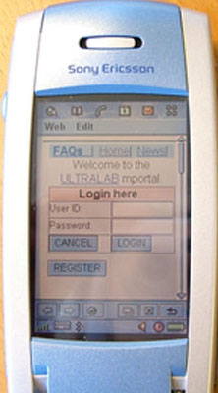 |  | 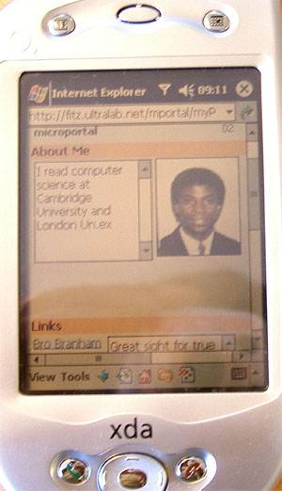
User login interface on a Sony User microportal when they first login
Ericsson P800 mobile phone into the IM system using an O2 XDA

The software was designed in an adaptable and intelligent way so as to detect various types of mobile devices accessing the IM server and to format or adapt the content to fit the particular device capabilities. Mobile devices have different screen resolutions, some have web browsers and some haven’t. Some are in colour and some aren’t and some can use a stylus while others do not have that capability. We confined our research to mobile devices that had web browsers only, as this made content adaptation more consistent and easier to implement. When a user logged in, they were automatically added to a list of users that could be sent an instant message. From within the user’s microportal, by clicking a link for the users that were online, a list of all the logged in users was displayed and by selecting a user from the list, a message could be composed and sent. Figures 4 below shows how the IM was composed and Figure 5 shows what the user inbox looked like when they had messages waiting. There were essentially two ways of sending IMs. The first method is as shown in Figure 4, where the message was composed in a similar way to ordinary email. The second method was where a chat window was displayed and the users could type in messages in real time to each other.
Figure 4 Figure 5
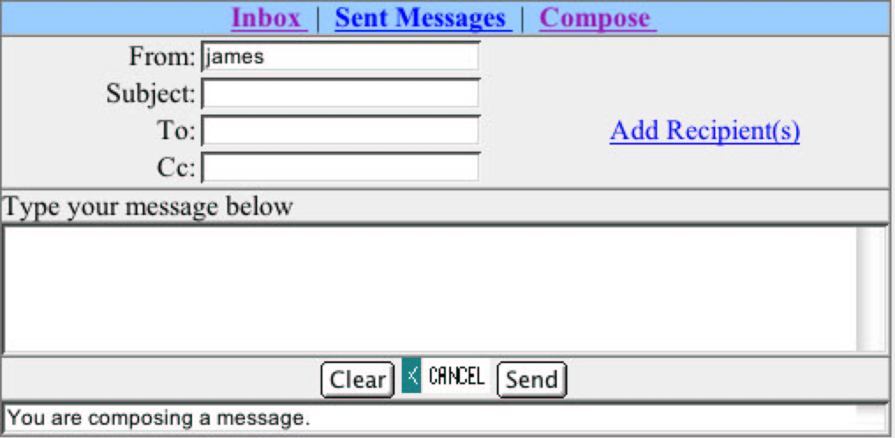 |  | 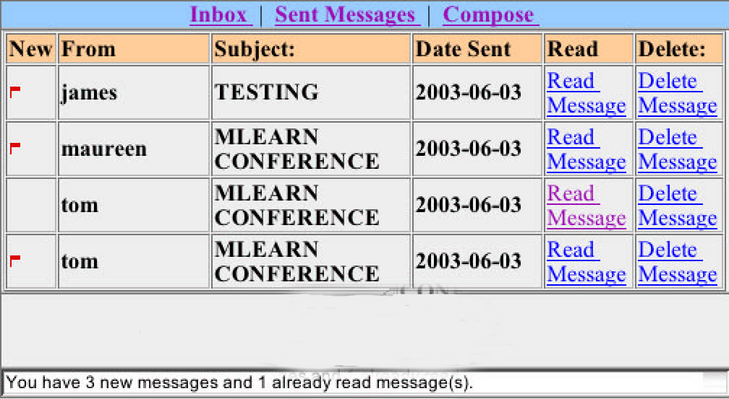
Compose IM Inbox showing IMs

When a user first logged in, they were taken to their microportal, which among other things, would have a message notifying them that they had messages waiting in their inbox. This could be either a text notification or a graphical notification, which showed icons representing unopened messages on the bottom part of the user’s microportal. Figure 5 shows the user’s inbox containing four messages, three of which had not been read, denoted by the small red flags. To read an IM, a user would click on the “Read Massage” link for the particular IM and the IM would then be displayed as shown in Figure 6, where an O2 XDA mobile phone was being used to read an IM. In addition to reading IMs as shown in Figure 6, they could also be forwarded to any recipients, whose user identifiers or names could be called up by pressing the “Add Recipient(s)” link, as shown in Figure 7.
Figure 6 Figure 7
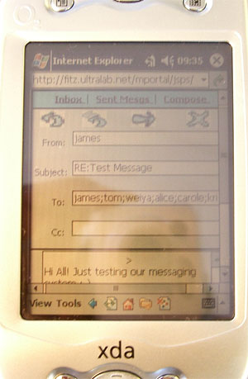 |  | 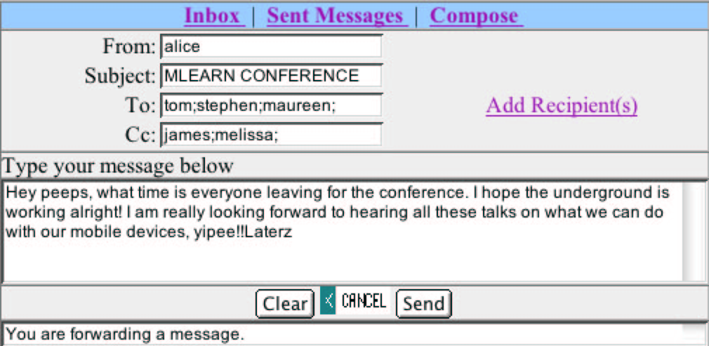
Read IM Forward IM

In addition to the IM service, users also had access to learning material provided via the LMS, accessed via the services interface on the microportal.
Discussion and conclusions
The device characteristics like resolution, web browser type, et cetera, were stored in a database to allow rapid creation of the microportal from the same code and not have different software for each device. So if a new device was introduced, there would be minimal change to the code viz. add the device type, resolution et cetera, to the database and add a small section to the code to detect that device type. This is one of the advantages of using Java as it is an object oriented language and is extensible and easy to modify.
In terms of the speed with which the web pages were loaded, there didn’t seem to be any appreciable difference after logging into the IM system. However, the Windows based devices i.e. the O2 XDA and the SPV Orange Smart phones seemed to take rather a long time in getting a connection established with the IM server. In terms of navigating the content once logged onto the site, as well as ease of text entry into the IM/chat window, the two mobile devices with the styluses i.e. the Sony Ericsson P800 and the O2 XDA in that order, were much easier to use, making the overall experience much more fun. Although the Handspring Treo 270 also has a stylus, because of it’s inability to render images properly and it’s low resolution, it was a bit awkward to use. The Nokia Communicator 9210 was the next best device in terms of content navigation and text entry, followed by the SPV Orange Smart phone. The best overall device for accessing the content and IM text entry usgae was the Sony Ericsson P800, followed by the O2 XDA. The Nokia Communicator also performed well, but the weight and size of the device made it more like a laptop rather than a mobile device, although it is a mobile phone. The most awkward device to use was the SPV Smart phone because of it lack of stylus and small keypad with awkward keys for navigation and text entry.
The instant messaging system presented showed that Instant Messaging can be a viable means of communicating and learning in higher education establishments. There was evidence to show that learning with mobile devices was good at reducing the formality of the learning experience, engaging reluctant learners and raising self-confidence. Unlike in a face-to-face classroom, in online distance education, attention needs to be paid into developing a sense of community in the group of participants in order for the learning process to be successful and IM is a natural medium for online community building and asynchronous peer discussions. With technologies such as web-enabled and IEEE 802.11x enabled mobile phones and personal digital assistants, IEEE 802.11x networks, mobile wireless communications are well on their way to becoming pervasive. So, for those mobile phones that are Wi-Fi enabled like the Nokia N80 and the Sony Ericsson P990i, with fully working web browsers, connection and usage costs become less of an issue as they can connect to their campus networks for free, surf the Web and take part in IM sessions, all for free. Users can also logon to the Internet via their wireless access points at home, if they have a broadband connection, which will not cost them anything in terms of accessing the Internet via their mobile phones. This will also make online distance learning much more attractive as it will break down the “distance” and the user will only be aware of the online community, irrespective of where they are physically located.

Future Research
Collaborative Filtering
The growth of Internet commerce has stimulated the use of collaborative filtering (CF) algorithms as recommender systems. Collaborative filtering combines the informed opinions of humans to make personalized, accurate predictions and recommend items of interest to other users. CF methods have been harnessed to make recommendations about such items as web pages, movies, books, and toys. Content-based filtering uses the speed of computers to make complete, fast predictions. However, very little research has been done on CF in education. As a follow on from this instant messaging research, we propose to use CF so that in searching for lecture notes, say, on a subject, a student can also see a list of books or other materials like presentations online, that most students found useful. If a user queries information about a particular sport in the university or school, they also get a list of recommendations on other activities like libraries or restaurants, cinemas, et cetera, that other users found useful. If a user queries information on where to get good material on writing an essay on some particular subject, they can get other information that other students found useful in their preparation when doing the essay. There is a lot of scope for students/pupils to get information online using their mobile devices and this will allow the lecturer to focus on the learning process instead of on the facts or information.

References
Alvestrand, H. (2002). Instant Messaging and Presence on the Internet, Retrieved July 14, 2006, from http://www.isoc.org/briefings/009/briefing09.pdf

Anderson, C.R., Domingos P. and Weld, D.S. (2001). Personalizing Web Sites for Mobile Users, Proceedings of the 10th International WWW Conference. ACM, 2001. pp. 565-575

Attewell, J. (2004). Mobile Technologies and Learning. Retrieved June 27, 2006, from the Learning and Skills Development Agency Web site: http://www.lsda.org.uk/files/pdf/041923RS.pdf

Chua, N.H., Scott, S.D., and Blanchfield P. (2005). Web-Page Adaptation Framework for PC & Mobile Device Collaboration. 19th International Conference on Advanced Information Networking and Applications (AINA'05).(Vol. 2, pp. 727-732)

Ivory, M.Y., Sinha, R.R., and Hearst, M.A. (2000). Preliminary Findings on Using Quantitative Measures to Compare Favourably Ranked and Unranked Information-centric Web Pages. Proceedings of the 6th Conference on Human Factors and the Web, 2000.
Kadirire, J. (2005a). Learning with Mobile Devices - A Microportal Design Experience, Recent Research Developments in Learning Technologies (2005), (Vol. 2, pp. 792-797). Retrieved June 27, 2006, from http://www.formatex.org/micte2005/7.pdf
Kadirire, J. (2005b). The Short Message Service(SMS) for Schools/Conferences, Recent Research Developments in Learning Technologies (2005), (Vol. 2, pp. 856-859). Retrieved June 27, 2006, from http://www.formatex.org/micte2005/4.pdf

Korzeniowski, P. (2004). Instant Messaging Opens New Security Holes. Retrieved June 27, 2006, from http://www.technewsworld.com/story/33271.html

Latest Mobile, GSM, Global, Handset, Base Station, & Regional Cellular
Statistics (April 2006). Retrieved June 27, 2006, from http://www.cellular.co.za/stats/stats-main.htm

Lenhart, A. and Shiu, L. (2004). How Americans use instant messaging. Retrieved June 27, 2006, from http://www.taylor.edu/weblogs/zblog/archives/2004/09/new_report_on_h.html

Mobile Phone Use Causes Brain Tumours says Swedes (April 5 2006). Retrieved June 27, 2006, from
http://cellular.co.za/news_2006/april/040506-mobile_phone_use_causes_brain_tu.htm

Mohan, R., Smith, J.R. and Li, C.S. (1999). Adapting Multimedia Internet Content for Universal Access. IEEE Transactions on Multimedia. (Vol. 1, No. 1, March 1999, pp. 104-114). Retrieved July 14, 2006, from http://www.research.ibm.com/networked_data_systems/transcoding/Publications/ieeemm.pdf

Paek, S. and Smith, J.R. (1998). Detecting image purpose in World-Wide Web documents. Proc. IS&T/SPIE Symposium on Electronic Imaging: Science and Technology – Document Recognition, San Jose, CA, January 1998

NESTA FutureLab. The future of mobile technology: learning on the run? Retrieved June 27, 2006 from http://www.nestafuturelab.org/viewpoint/vision/vision_01_04.htm

Roibas, A.C. and Sanchez, I. A. (2002). Pathway to m-learning, Mlearn 2002. Proceedings of the European Workshop on Mobile and Contextual Learning. 20th and 21st June, 2002

Scott, S.D. and Koh, Y.H. (2003). Design Metrics and the Adaptation of Web-page Content Chunks for PDAs, Proceedings of the 3rd International Conference on Information Technology in Asia, 2003, pp. 261-268

Scott, S.D. (2003). Edge-based Algorithms For Determining How Far An Image Can be Shrunk. Proceedings of IEEE’s International Conference on Robotics, Vision, Information and Signal Processing (ROVISP), 2003

UK GSM Text Messaging Numbers Boom (December 20 2003). Retrieved June 27, 2006, from http://www.mobileoffice.co.za/news_2003/121903-uk_gsm_text_messaging_numbers_bo.htm

UK TEXT MESSAGING LOVE AFFAIR SURGES AHEAD (June 27 2006). Retrieved June 27, 2006, from http://www.text.it/home.cfm

Ultralab: BA Hon. Learning, Technology and Research (2006). Retrieved June 27, 2006, from the Ultralab, Anglia Ruskin University Web site: http://www.ultraversity.net

Vetter, R., Heath, B., Herman, R., Lugo, G., Reeves, J., Ward, C. R. (2005). Developing a Mobile Learning Environment to Support Virtual Education Communities. Retrieved June 27, 2006, from

http://people.uncw.edu/vetterr/ncsu-mle-2005.ppt

Walker, C. (2005). WFU first with campus pilot of pocket PC phones. Retrieved June 27, 2006, from http://www.wfu.edu/wfunews/2005/082405m.html

Walton, S. (2005). Qualifications and Curriculum Authority. The eVIVA project: Using e-portfolios in the classroom Retrieved June 27, 2006, from http://www.qca.org.uk/10359.html

